Version Control

Samuel Cooke – s251388

Repository Link
Link: https://github.com/s251388/AIE-2.1.4-Statistics.git
Screenshot:
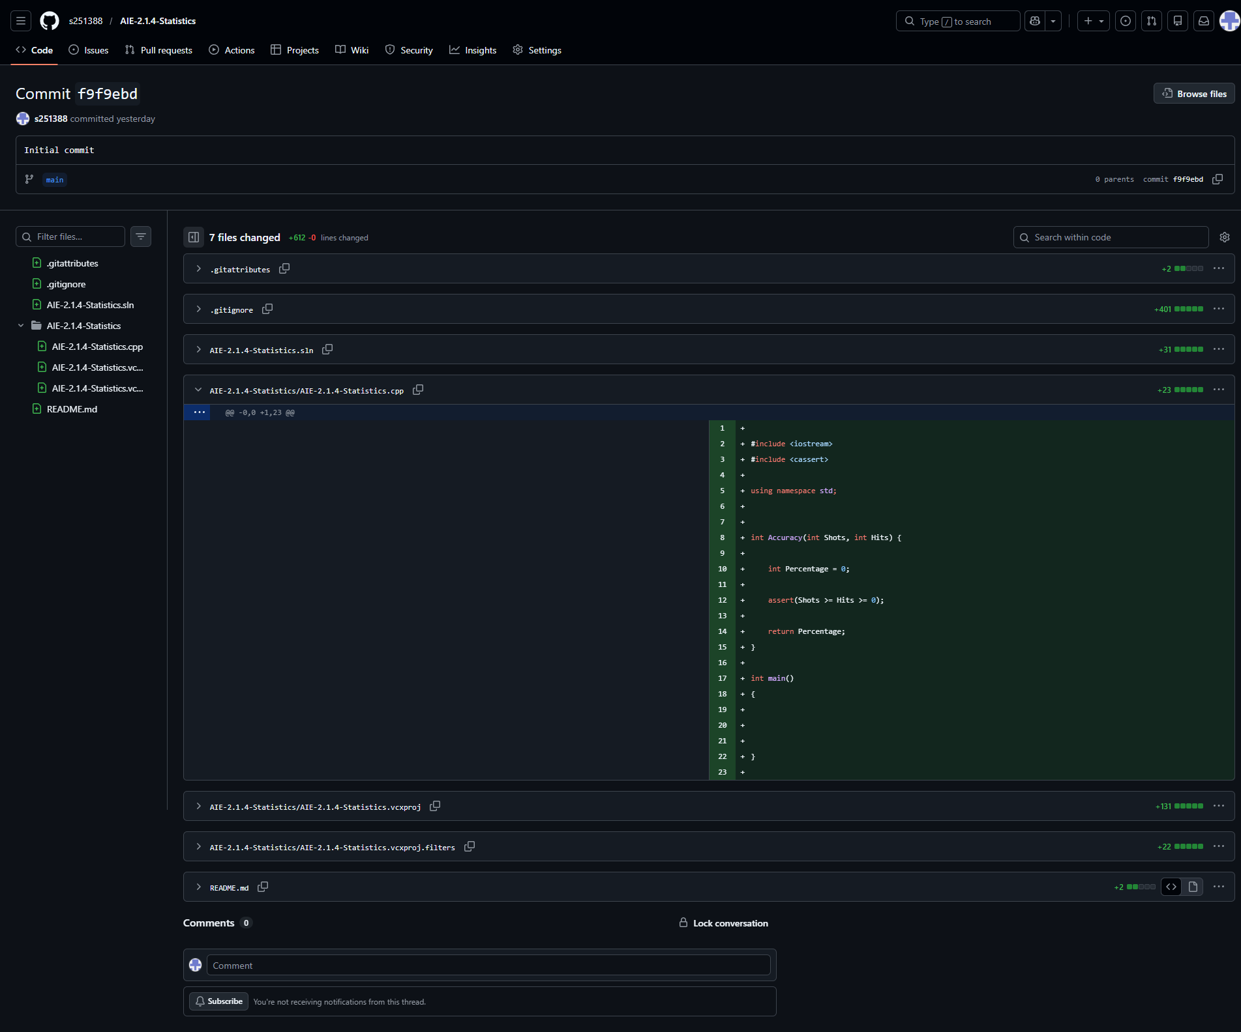
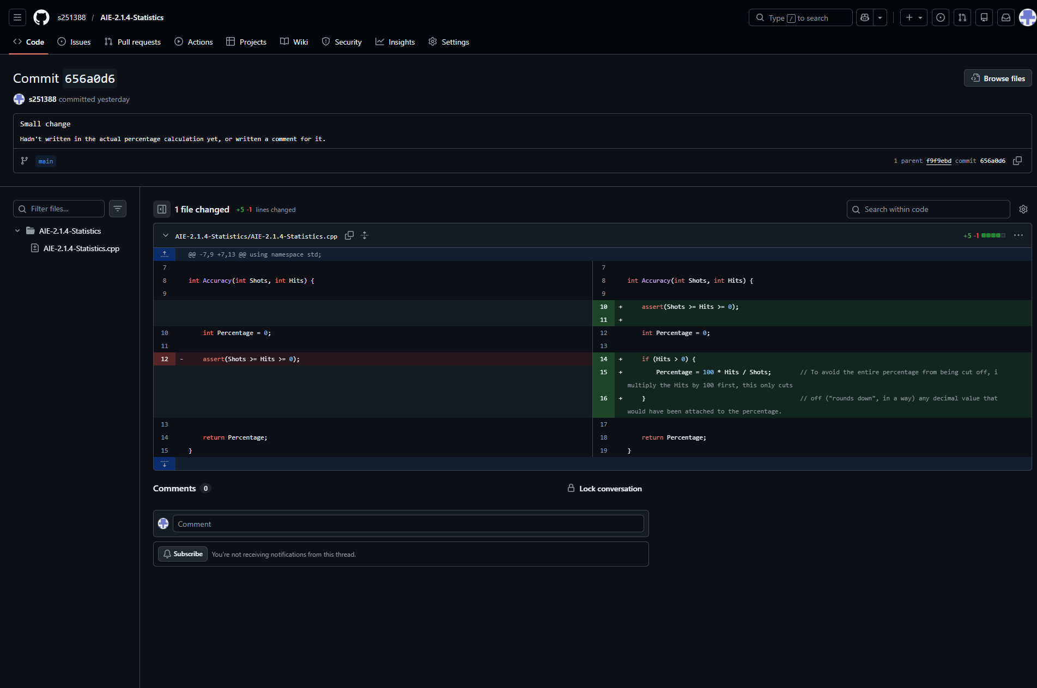
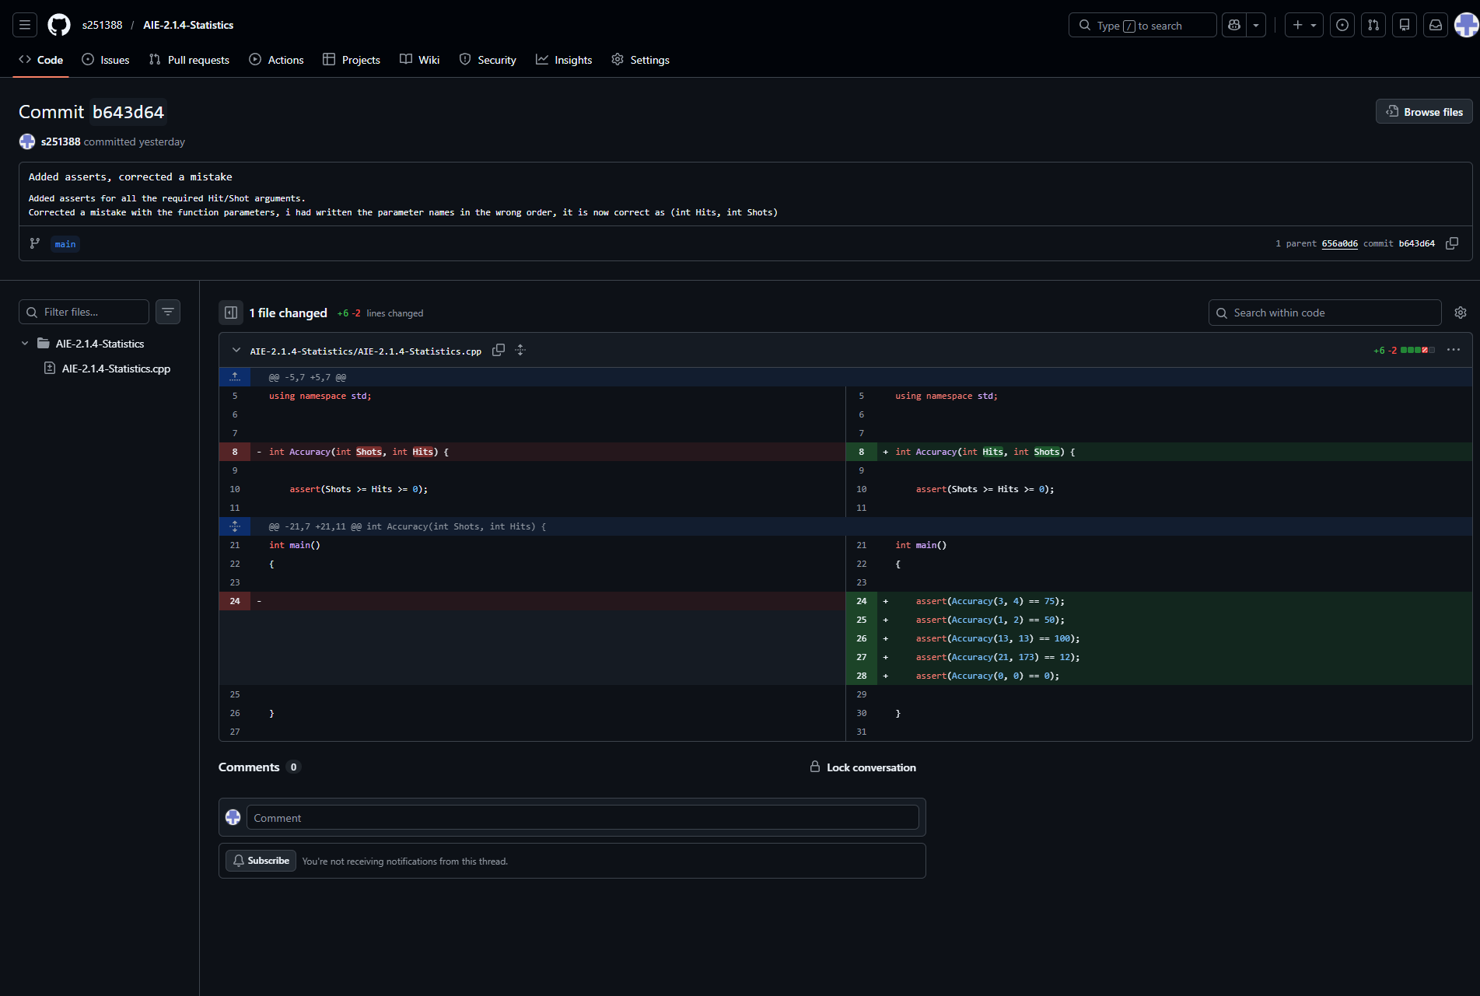

Resources:
- N/A, random knowledge from other projects
- Random information from site snippets in Google search

Challenges
Write a description of the challenges, mistakes made, or problems you personally encountered, and what you did to overcome, work around, or resolve these issues. (100 - 300 words).
I had fed the values into the function in the wrong order which caused me problems i couldn’t find for a while.
I wasn’t sure about how to round down an int while keeping to what the assessment task asked of me, but later found that ints seem to automatically round down if you attempt to assign them a non-whole number.

Weaknesses
Write a list of personal weaknesses regarding version control and ways you could resolve these weaknesses. (100 - 300 words).
I’m still having trouble fleshing out my own consistent “style” with writing code.
It’s feeling awkward sending separate commits for the function, and the testing of the function, i feel like normally these would always be committed together, i assume this is only being done for these assessment projects for educational purposes.

